**INTRODUCTION TO TML**

Tata Motors Limited, a USD 42 billion organization, is a leading global automobile manufacturer with a portfolio that covers a wide range of cars, sports vehicles, buses, trucks and defense vehicles, heavy and light commercial vehicles, wide range of SUVs and the world’s most economic small car. The companies’ marque can be found on and off-road in over 175 countries around the globe.

Tata motors was established in 1945, having more than 60,000 happily employed professionals. The company is having a remarkable penetration in the global market with more than 6,600 sales and service points already delivered more than 9 Million Vehicles, hitting the roads.

Tata Motors is part of the USD 100 billion Tata group founded by **Jamsetji Tata in 1868**. Sustainability and the spirit of ‘giving back to society’ is a core philosophy and good corporate citizenship is strongly embedded in the DNA of the company.

Tata Motors is India’s largest automobile company delivering its customers a proven legacy of leadership with respect to customer-centric technology. The company is driving the transformation of the Indian commercial vehicle landscape by offering customers leading edge auto technologies, packaged for power pack performances and lowest life-cycle costs.

The companies’ new passenger cars are designed for superior comfort, performance, mileage and efficiency. The focus on future readiness with an exciting set of tech-enabled mobility solutions in pipeline is keeping the company remarkably ahead of the market competition. The design and R&D centers located in India, UK, Italy and Korea strive to innovate new products that achieve performances that will fire the imagination of GenNext customers, specifically focusing on the areas that will leave an immediate impact on first impression and a lasting impact over time on potential buyers’ minds by introducing the philosophy of EEE (Exciting, Expressive and Extraordinary) and III (inviting, intelligent and in-touch) for Vehicle Exterior and Interior subsequently.

The one thing that energies and drives the motivation of the enthusiastic employees of the organization lies in its mission statement, - “To be passionate in anticipating and providing the best vehicles and experiences that excite our customers globally''

**PRODUCTS:**

The company’s main product lines are:

**Passenger cars & utility vehicles**:

**Truck & buses:**

**Tata Nano Plant at Ahmedabad**

Tata Motors' plant for the Tata Nano at Sanand, in Ahmedabad district of Gujarat, marks the culmination of the Company’s goal of making the Tata Nano available to hundreds of thousands of families, desirous of the car a safe, affordable and environmental friendly mode of transport. The capacity of the plant, to begin with, will be 250,000 cars per year to be achieved in phases, and with some balancing is expandable up to 350,000 cars per year. Provision for further capacity expansion has also been incorporated in this location.

Built in a record time of 14 months starting November 2008, the integrated facility comprises Tata Motors’ own plant, spread over 725 acres, and an adjacent vendor park, spread over 375 acres, to house key component manufacturers for the Tata Nano.

In line with latest world-class manufacturing practices, the Tata Nano plant has been equipped with state-of-the-art equipment. They include sophisticated robotics and high speed production lines. Conscious of the critical need of environment protection, the plant has energy-efficient motors, variable frequency drives and systems to measure and monitor carbon levels. These are supplemented with extensive tree plantation, sustainable water sourcing through water harvesting and ground water recharging and harnessing solar energy for illumination.

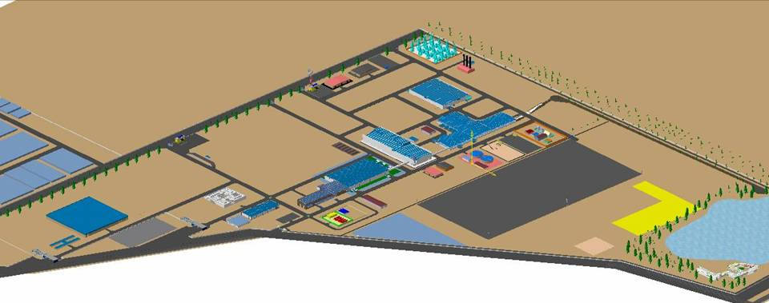

3D Arial view of sanand plant

**Ahmedabad Plant Layout**

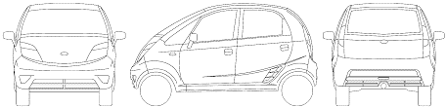

**Powertrain Shop**

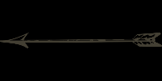

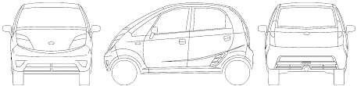

**Press Shop**

**BIW Shop**

**Paint Shop**

**TCF Shop**

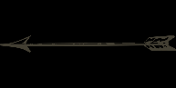

Trim Chassis Final, i.e. TCF Department is responsible for assembly of vehicles. It receives the painted body from paint shop and delivers the final assembled, equipped and well tested body to the supplier end. Therefore, TCF shop is considered as the most critical and crucial shop as the error or defect passing from this shop could not be detected or rectified later.

**TCF Shop at a Glance**

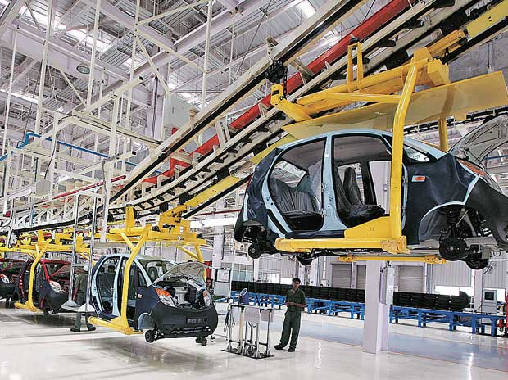The various lines associated with the TCF shop are:

* Under Body line 01
* Trim line 01
* Trim line 02
* Under Body line 02
* Under Body line 03 & 3A
* Under Body line 04
* Mechanical line
* 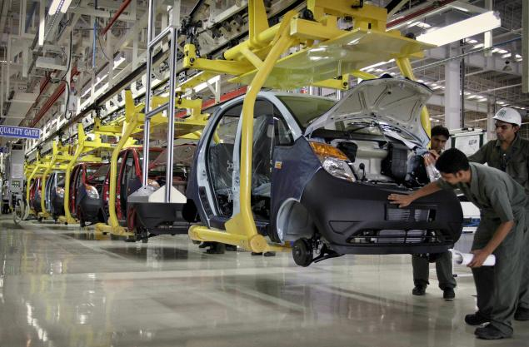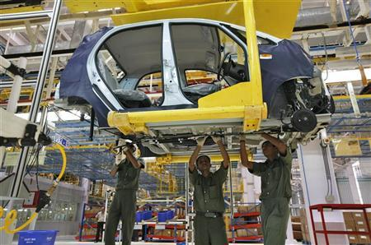Sub Assembly lines

1) Door line

2) Cockpit line

3) Cradle line

At the end of mechanical line there is a quality gate where final quality checking is done. Processes sequenced after the vehicle passes final Mechanical line:

* In the wheel alignment area alignment of wheels is checked.
* In shower room the vehicle is kept in for 3 minutes in a continuous shower falling from all the sides of the vehicle. After coming out of the shower room vehicle is properly inspected and checked whether there is any leakage of water into the vehicle body.
* A Roll and Brake test is a small dynamic test carried out in order to check the performance of the vehicle under certain controlled parameters, signifying how exactly it can perform in adverse conditions.
* At the end if any fault found, then the vehicle is moved to NFT area for repairing work.

**Safety Norms**

Tata considers safety as the first and the most important step in training. Safety has a critical and important part in each and every shop of the Industry. Every employee must be aware of the safety norms prevalent in his/her shop and should implement them to their best. Some standards are being set by TML for categorizing different hazards and their preventive measure. ‘F’ stands for fire, ‘M’ for medical aid and ‘S’ for security. Employee is beforehand taught about the safety guides before working in his/her workstation.

Some of the Machines/Tools/Operations used in the Automobile Industry Specially TCF Shop may be dangerous to the employee’s safety, hazardous to his/her health or harmful to the environment if handled or used incorrectly.

Major Hazards or Accidents while working in TCF shop include:

* Due to heavy machine or tools
* Due to moving conveyor
* Fire and explosion

Accidents can be eliminated by wearing the Proper Personal Protective Equipment (PPE) at all times which includes the following:

* Safety shoes
* Helmet at all times, especially while working Under car body.
* Protective covers for belts and other metal equipment’s, in order to avoid scratches.
* Hand gloves

The ‘SQDCM’ quality concept is followed in TCF Shop which stands for ‘safety, quality, delivery, cost and morale respectively followed in a sequential manner. Thus safety is considered first step in any progress aimed at achieving technological advancement. Everyday morning meetings are held with the workers to discuss various issues starting with safety. Any issue found genuine is immediately taken care of to avoid any accidents.

**PROJECTS**

1. **Study and Analysis of Assembly and Sub-Assembly lines in TCF Shop**



1. **Under Body (UB) 01**

|  |  |
| --- | --- |
| **No. of Stations** | **8** |
| **Quality Gates** | **8th** |
| **Critical to Quality (CQ) Gates** | **5th** |

**TOOLS & EQUIPMENTS:**

Battery gun, pneumatic gun, angular gun’ DC tool’ barcode scanner, silicon sealant gun’ and fuel tank lifter trolley.

**PARTS ASSEMBLED:**

GSL cable, clutch cable, accelerator cable, AC and heater pipe, coolant pipe, rack and pinion sub assembly, fuel tank, canister, brake and vacuum pipe, firewall.

**OPERATIONS:**

Here operations are performed under the body including front and rear of the vehicle. Body is hanged on the hangers. Various operations include insertion of firewall, fitment of rack and pinion, fitment of GSL cable, fuel pipe, coolant pipe, AC and heater pipe, canister, breather pipe and various grommets.

At the end there is a Quality Gate at station 8 for checking any faults for various processes performed in the UB01 line. The vehicle is then transferred to TRIM01.

1. **Trim 01**

|  |  |
| --- | --- |
| **No. of Stations** | **22** |
| **Quality Gates** | **12th & 22nd** |
| **Critical to Quality (CQ) Gates** | **13th, 14th &18th** |

**TOOLS & EQUIPMENTS:**

Battery gun, angular gun, pneumatic gun, DC tool, barcode scanner, manipulator, brake drum mounting fixture.

**PARTS ASSEMBLED:** Hood striker, tail gate lock, carpet clips for floor, tail gate handle, latch, mascots and emblem, firewall insulation, wiring harness, engine manifold, clutch cable clip, insulation, HVAC unit, ECU, fuse box, brake booster, master cylinder, brake and accelerator pedal, brake switch, front brake drums floor carpets and various grommets.

**OPERATIONS:**

Some of the common operations include Installation of Brake Booster, SRS ECU for Airbag fitted, Matting, AC setup installed, BCM fitted and Brake pedal installed.

1. **Trim 02**

|  |  |
| --- | --- |
| **No. of Stations** | **23** |
| **Quality Gates** | **11th & 23rd** |
| **Critical to Quality (CQ) Gates** | **1st, 4th, 8th & 19th** |

**TOOLS & EQUIPMENTS:**

Battery gun, angular gun, pneumatic gun, DC tool, barcode scanner, manipulator, plier, mallet, wrench, glass glazing machine and vacuum cup.

**PARTS ASSEMBLED:**

Struts, sun wiser, roof light, wiper motor, cock pit assembly, water tank, steering column, combi switch, seat, seat belts, A, B and C pillars, condenser sub assembly, GSL adapter, tail gate trims, tail gate glass, wiper, steering wheel, control panel and wind screen.

**OPERATIONS:**

First of all, dash board is assembled with the help of cockpit manipulator. Front struts are tightened. Other operations include fitment of A, B and C pillar, steering column, all four seat belts, water tank, combi switch, wiper motor, controllers, seat fitment, condenser, Quarter glass, windshield-tail gate glass fitment.

1. **Under Body (UB) 02**

|  |  |
| --- | --- |
| **No. of Stations** | **15** |
| **Quality Gates** | **15th** |
| **Critical to Quality (CQ) Gates** | **3rd, 5th, 8th, 10th, 11th, 12th, 13th & 14th** |

**TOOLS & EQUIPMENTS:**

Battery gun, angular gun, pneumatic gun, DC tool, barcode scanner, spanner, wrench, plier, PLC controller for RGV and marker.

**PARTS ASSEMBLED:**

RTB, Rear brake hose, fuel filler and breather pipe, A, B & C mounting, front suspension, ARB mount.

**OPERATIONS:**

Various operations include mounting of rear twist beam, rear brake hose, fuel filler and breather pipe, Engine A, B, C mounting, assembly of lower link, front suspension setup fitted, ARB mounted.

1. **Under Body (UB) 03**

|  |  |
| --- | --- |
| **No. of Stations** | **05** |
| **Quality Gates** |  |
| **Critical to Quality (CQ) Gates** | **3rd, 4th & 5th** |

**TOOLS & EQUIPMENTS:**

Battery gun, angular gun, pneumatic gun, DC tool, Nitrogen tester & Multifilling machine

**PARTS ASSEMBLED:**

Wheel arch, seal, wiper motor, EMS

**OPERATIONS:**

Here first of all adjustment of clutch cable free play is done. Then assembly of wheel arch, wiper motor followed by nitrogen testing and installation of EMS (Engine Management System). At last filling of brake oil, coolant, water & AC gas is done by multifilling machine.

1. **Under Body (UB) 03-A**

|  |  |
| --- | --- |
| **No. of Stations** | **19** |
| **Quality Gates** | **19th** |
| **Critical to Quality (CQ) Gates** | **5th** |

**TOOLS & EQUIPMENTS:**

Angular gun, pneumatic gun, DC tool, BDF machine

**PARTS ASSEMBLED:**

Tailgate, Battery, Front and Rear Bumper, Head and Tail lamp.

**OPERATIONS:**

Here first of all head and tail lamp are fitted followed by installation of Battery and its connection, Front and rear Bumpers are fitted and then at last static BDF ECU test is performed.

1. **Under Body (UB) 04**

|  |  |
| --- | --- |
| **No. of Stations** | **07** |
| **Quality Gates** | **5th** |
| **Critical to Quality (CQ) Gates** | **7th** |

**TOOLS & EQUIPMENTS:**

Barcode scanner, battery gun, pneumatic gun, bumper shuttle trolley, pneumatic tire loader, spare wheel belt conveyor, hammer and AC gas leak tester.

**PARTS ASSEMBLED:**

Bumper screws, All four wheels

**OPERATIONS:**

Refrigerant gas leakage is tested, AC cover is fitted. Attachment of all four wheels along with spare wheel and tightening of wheel bolts with the help of multi spindle nut runner is done before going to the final quality gate.

1. **Mechanical Line**

|  |  |
| --- | --- |
| **No. of Stations** | **16** |
| **Quality Gates** | **13th to 16th** |
| **Critical to Quality (CQ) Gates** | **2nd, 5th & 6th** |

**TOOLS & EQUIPMENTS:**

Barcode scanner, battery gun, pneumatic gun, torque wrench, spanner, petrol filling station, printer, MFI machine (ECOS), computer control for ECOS, static ADF tester, brake pedal testing machine, puller and door velocity gauge.

**PARTS ASSEMBLED:**

Brake light, Rear carpet clip, front and rear doors and primary seal.

**OPERATIONS:**

Here testing and checking of electrical components is done mainly such as ECOS test, along with brake pedal testing. Door velocity and effort is also checked. Door setting is also done. Then a static ADF test is done to check the ECU issues after door fitting. There is a quality check for ECU flashing and diagnosis.

At the end of mechanical line there is a quality gate where final quality checking is done.

**Sub-Assembly Lines**

**Door Line:**

Operations undertook are:

* Bell crank lever assembly and fitting into the door is done.
* Pop up knobs, door wiring harness, glass guide channel, door glass sub assembly, glass insertion and the winding mechanism is put up.
* Door electrical test done for roof lamp, power window & roof top, door pads attached.

**Cockpit Line:**

Fitment of various components such as I-cluster, airbag, music system etc on the cockpit panel takes place at Cockpit Line.

**Cradle Line:**

Fitting exhaust system, radiator, radiator pipes and other engine dressing components.

**Tyre Sub Assembly:**

Rim is placed into the tire and inflating, all done through the machine and finally through a belt conveyor sent to UB4 where its fitment to the car is done. There is a Suspension cell beside the tyre sub assembly, where the brake drum assembly is done.

**Tests after Mechanical Line**

**VIBRATION BED TEST:**

After the ME line, there is a vibration bed tester where the vehicle’s all 4 tyres are exposed to periodic vibrations.

**WHEEL ALIGNMENT MACHINE:**

It sets the caster, camber and toe of the tires with a specified range of +/- 0.09 degree for toe and +/- 0.75 degree for camber. Head lamp focus is also done by the sensors.

**ROLL & BRAKE TEST:**

The machine tests the vehicle’s brakes by accelerating the car to 60 Kmph and then applying the forward brakes and at 10 Kmph for parking brakes. Parameters as drag force, brake force and parking brake force are checked to be within limits.

**CANOPY AND SHOWER TEST LINE:**

Various other vehicle tests of the body are performed in canopy and water jets are applied at high pressure to the vehicle to check out for any leakages into the car.

**PROJECTS**

1. **Productivity and Quality Improvement – TCF Mechanical Line**

* Collection of ADF-BDF data and filter out Top Problem Areas at station level
* Quality Improvement through Deployment of Kaizen Event Methodology

**What is BDF-ADF?**

BDF Test & ADF Test is carried out for the checking of Vehicle Electrical & Electronic system in Ignition ON Cycle. This test is done with the help of Toughbook which is used to capture vehicle parts electronic data i.e. voltage or current level and help us to identify parts fault with code if any.

Electrical system testing of vehicle is carried out in two stages i.e. BDF & ADF in order to improve EOL FSO.

* The BDF test is carried out at Station 16 and 17 in UB3-A.
* There are total 9 ECU’s in BDF testing and varies as per the model.
* The average time calculate to carry out the test is 3 mins 05 secs and changes according to every model.
* The Result of BDF test is seen and accordingly the car is repaired Online or else Offline as per the intensity and scope of repair time required.

**Model Wise ECU Tests Carried Out in BDF**



**BDF-ADF data collection and analysis**

* The BDF and ADF data at their respective stations was collected for 12 days, wef 18th May’16 to 31st May’16
* From the data top issues areas or ECU were detected and represented in the form of BDF tree
* In BDF Tree, the top issue variant was first chosen and then in that particular variant the top issue ECU was detected
* After this, the top 5 issues of the particular ECU were marked and passed for analysis

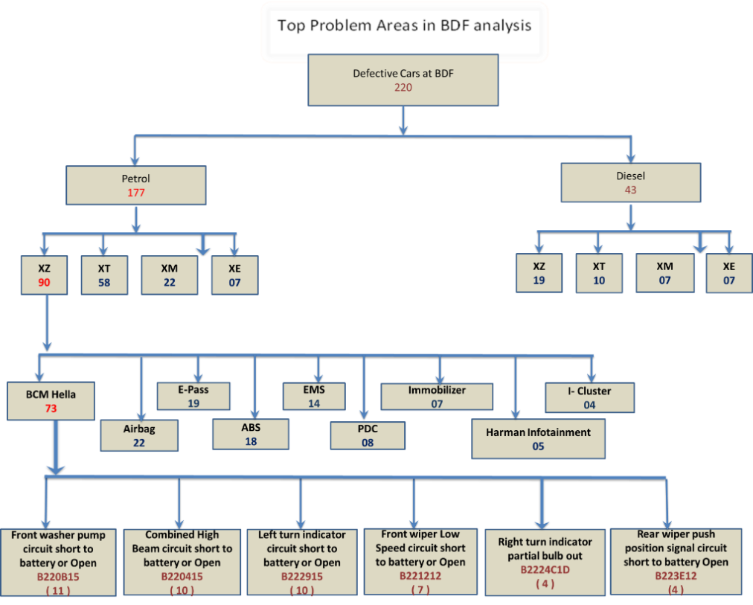**Top Problem areas in BDF Analysis**

**BDF ECU-Wise Analysis**

**Main Project Work**

* Quality Improvement through Deployment of Kaizen Event Methodology
* BDF-ADF Data for May’16 was collected and problem areas were marked
* After analyzing the Final mechanical line data, BDF-ADF issues were reported at the top, contributing approximately 13% at mechanical line
* Then a break-up for ADF and BDF issues was made, which reported about 9% problem in BDF
* Quality Improvement through Deployment of Kaizen Event Methodology

**Theme Selection**

**ADF-BDF Break-out for May’16**

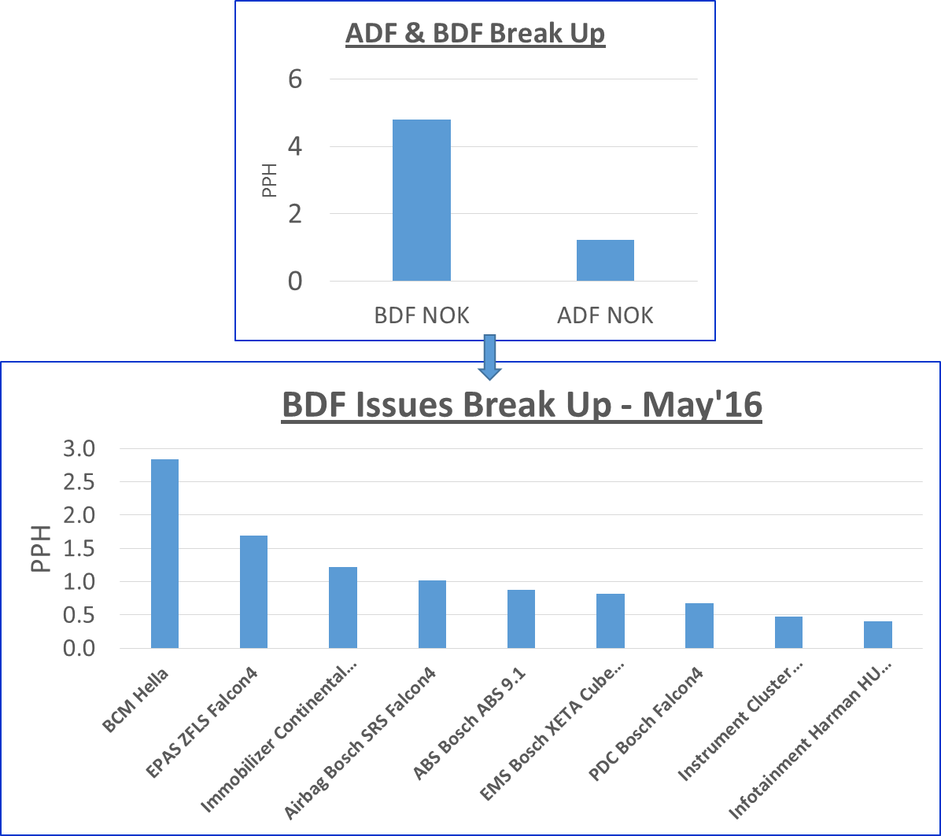

* Observing the break-up for ADF-BDF issues, conclusion was made that the problem most persistent at mechanical line was of BDF
* Then we arranged the errors with their error-codes under their respective ECU’s in order to dwell out a clear picture as to which ECU is contributing how much percentage of errors.
* For this purpose, we used the Pareto tool and made ECU wise pareto charts for each respective ECU
* Then we used 80-20 percentage approach for each ECU and marked the top 80% contributing errors, discarding the left 20%

**Grasping Current Situation and Set Target**

* **ECU-Wise Pareto for BDF Issues**

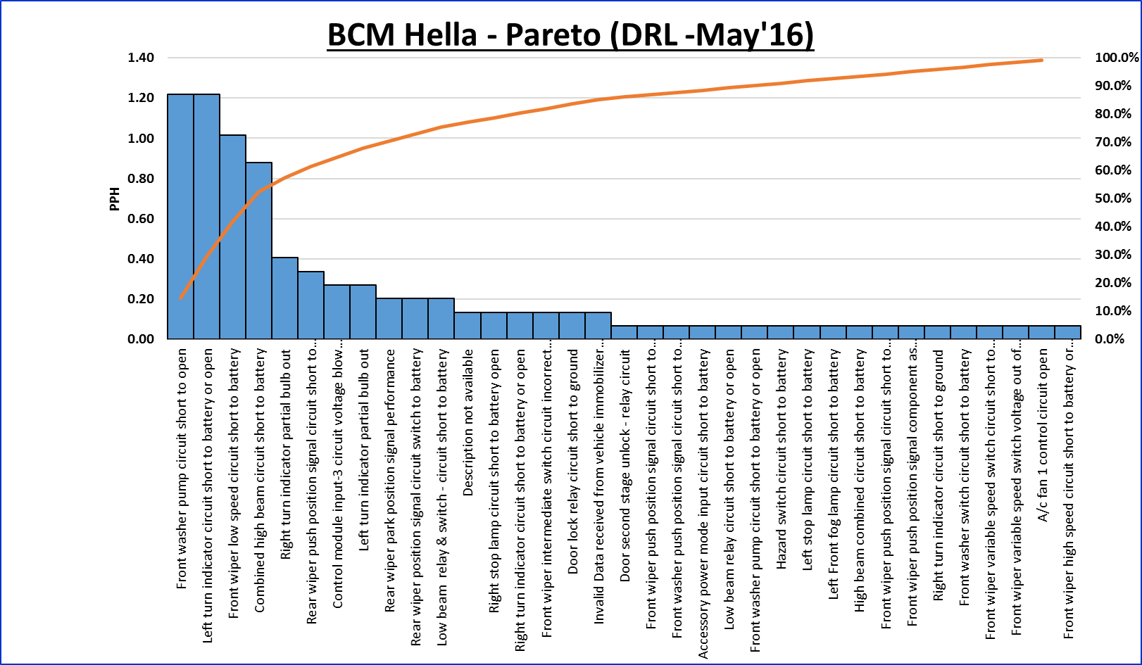

* Similarly Pareto Charts for each ECU i.e. E-PAS, Immobilizer, Airbag, PDC, ABS, EMS, Instrument cluster and Harman were made and then top 80% issue areas were taken into consideration for future analysis

**Task Allotment**

* After Analyzing the top order issues of each ECU, Kaizen team was formed according to each Agency to whom the issue or error was associated
* The team individually focused on their allotted issues and updated the rest team about their progress during a common meeting point
* Also if help needed by another agency member is discussed during the daily meeting
* Agencies involved in the respective BDF Kaizen event were- Process related Agency, Parts related Agency, SQ, ERC and TS.

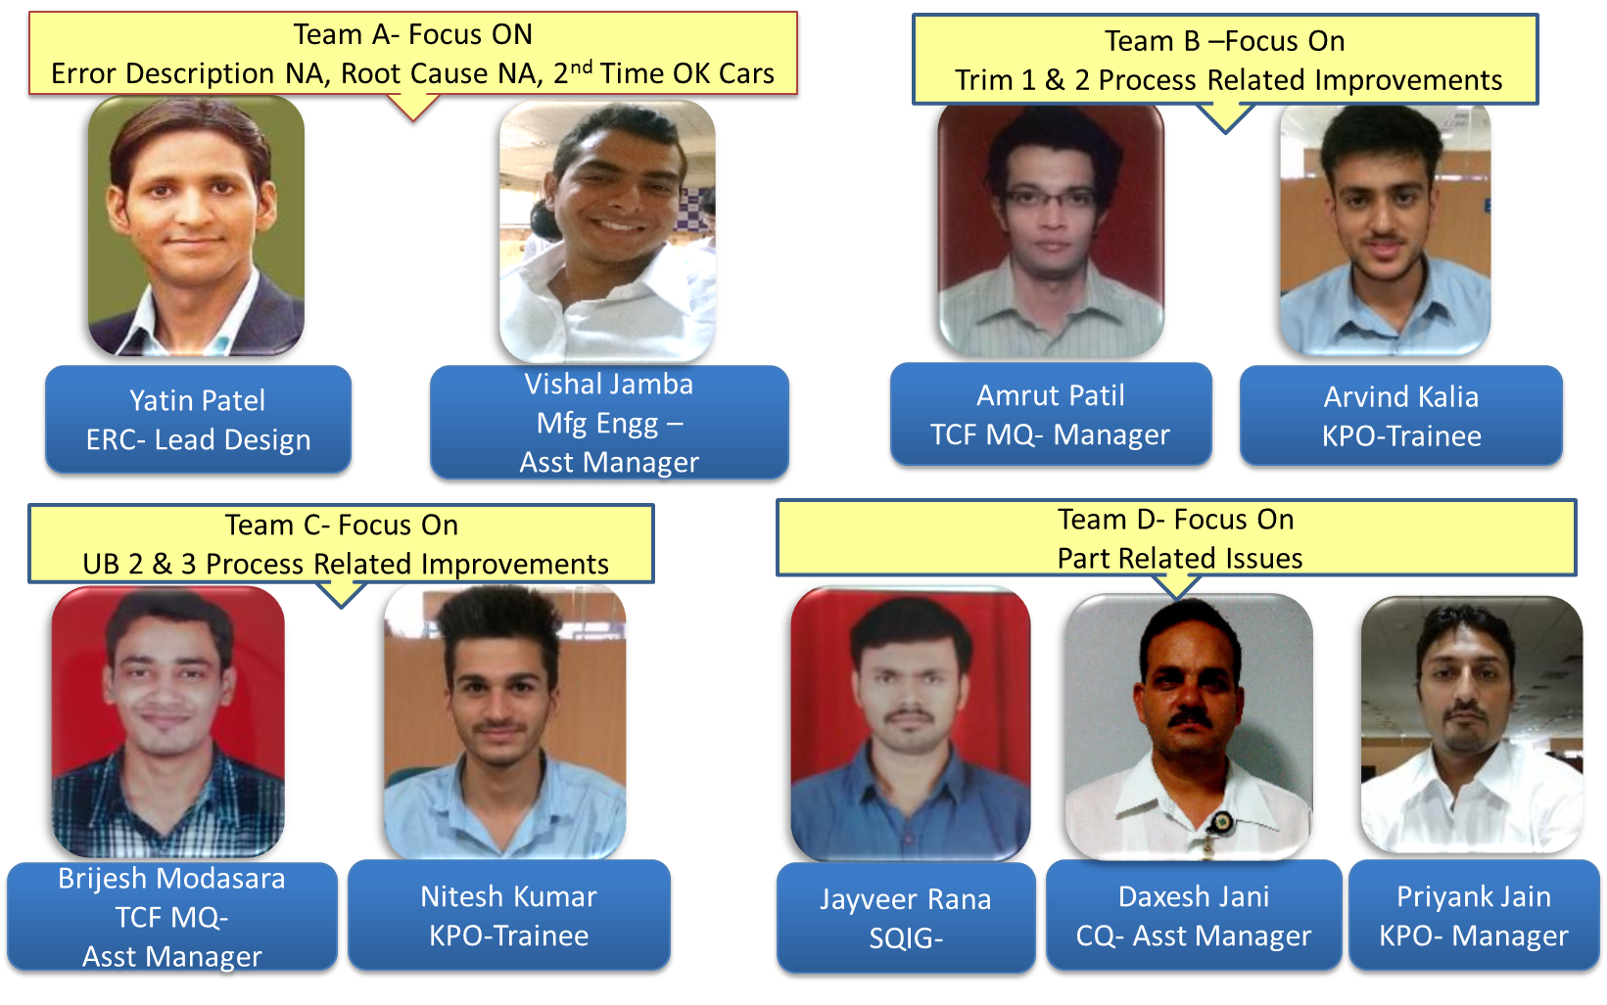**Kaizen Team Formation According to Concerned Agency**

**Analyzing the Factors & Creating a Plan**

* **Error and Action Plan Sheet**



* For Process related errors, at station level One Point Lesson sheets were displayed for visual understanding of the operator. Along with this marking was initiated which would act as a poka-yoke for the operator while making the coupler connection.
* This also helped in increasing the efficiency of the operator

**Developing and Implementing Kaizen**

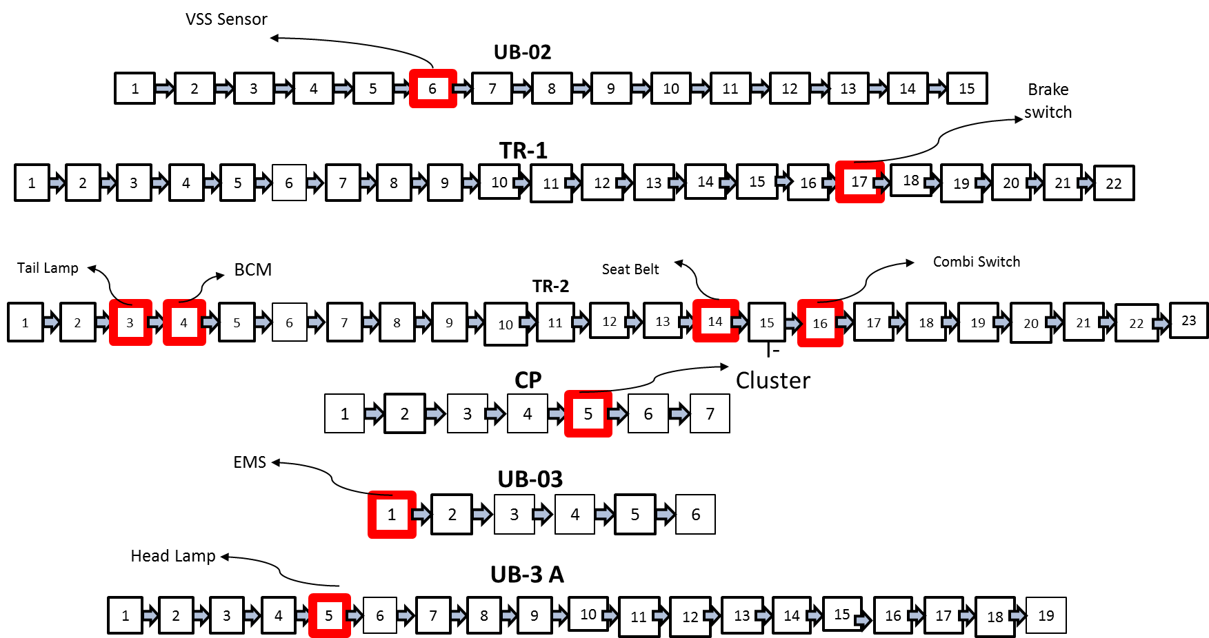

**OPL Display & Marking Stations- Process Improvement**

**Kaizen-1**

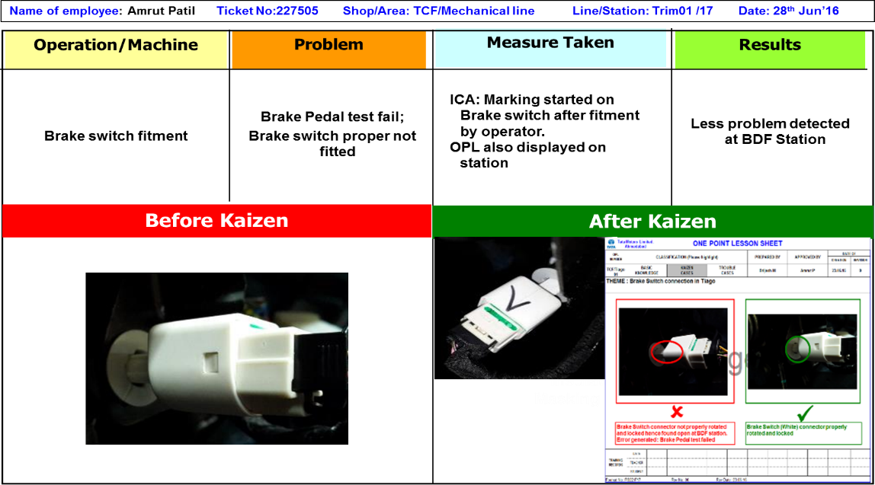

For the process related errors, similar One Point Lesson sheets were made for BCM, Seat belt, Rear and Front wiper, Clock spring, Combi-switch, Instrument cluster, EMS, Head light and Airbag.

**Confirming Effectiveness and Standardizing the Process**

**BDF PPH (Before & After)**

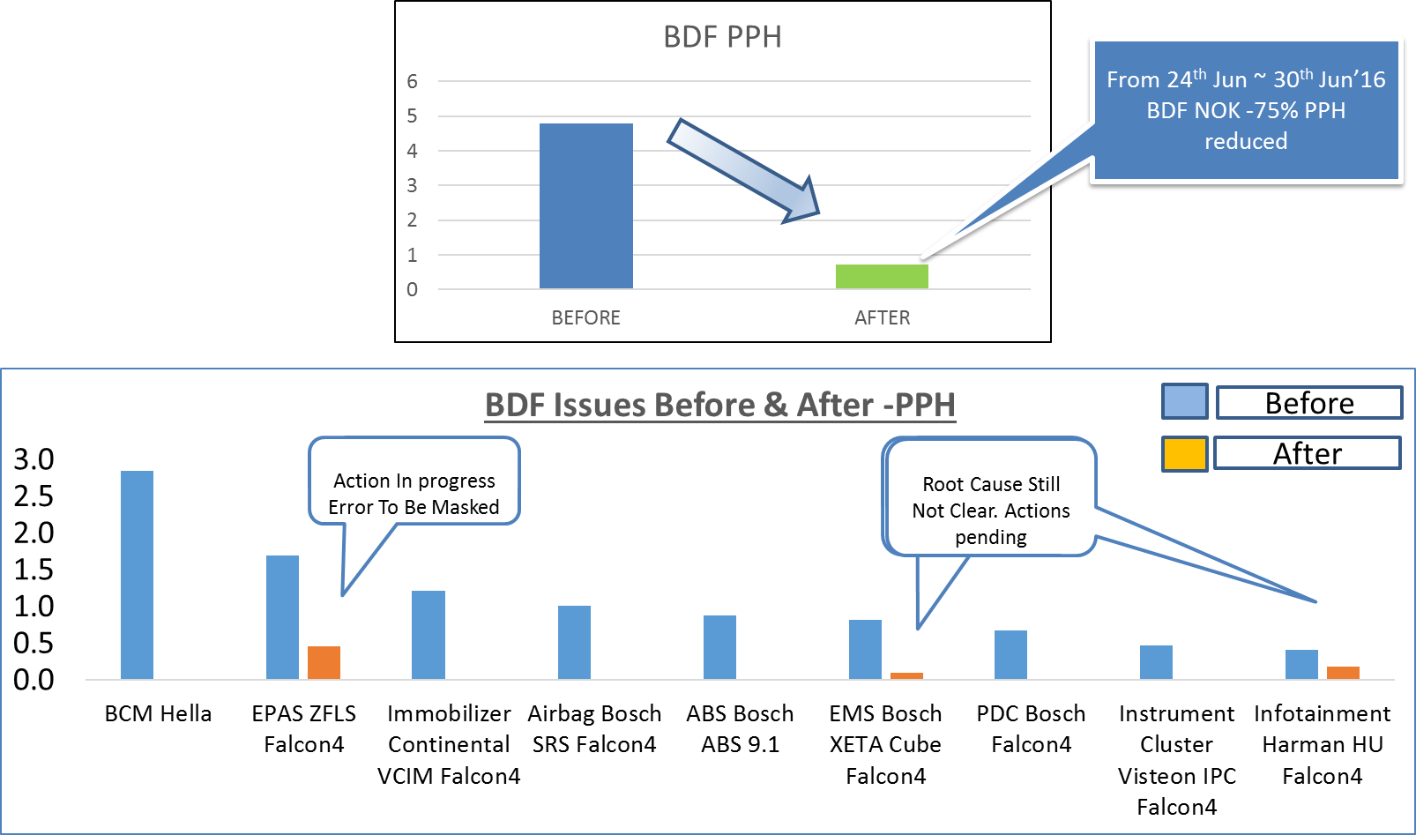

‘

* Post Event collection of the BDF data and analysis, there was approximately 75% reduction in BDF issues at Final Mechanical Line
* Day-wise audit checks were performed to check whether the alloted marking scheme was obeyed by the operators and line supervisors.
* The Senior Management reviewed the event and compiled the data. They reported reduction in ECU errors which therefore resulted in reduction of DRL at mechanical line and more number of First Shot OK cars manufactured.

**Conclusion**

* About 75% reduction in BDF PPH was observed after the completion of the BDF project
* Out of total 44 errors, ICA for 36 were found and PCA for 7 were found
* At the start of the project, there were 12 errors with no root Cause, which was later reduced to only 3 error
* At areas of process related issues, setting up of OPL and marking cycle lowered down the chances of omitting errors
* Software updation gave proper error description to the errors which were earlier remarking ‘No description Available’
* Approx. 10% reduction in DRL at Final Mechanical Line was observed